Lab Exercise 1

Performing CRUD Operation on Containers
Objective: Performing CRUD Operation on Containers

Tools required: Docker Configuration

Pre-requisites: Ubuntu Configuration, Docker

Steps to be followed:
- Pulling a Docker image
- Creating a new container
- Stopping the container
- Listing all the containers
- Deleting the container
- Removing the image

Step 1: Pulling a Docker image
1.1 Open the terminal and pull an image using the command:
sudo docker pull nginx
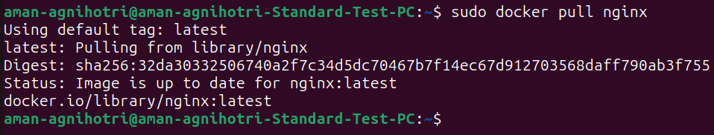

1.2 List all the docker images to check the newly pulled nginx image:
sudo docker images
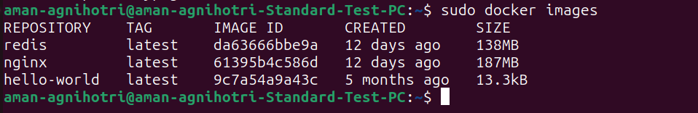

Step 2: Creating a new container
2.1 Create a new container from the nginx image:
sudo docker run -dt -p 81:81 nginx

2.2 List all the running containers to check the newly created container. You can find various details like port of container, it’s time of creation and ID.
sudo docker ps
Step 3: Stopping the container
3.1 Use the following command to stop the running container. (You can also us the container ID to stop the container: sudo docker stop CONTAINER_ID)
sudo docker stop CONTAINER_NAME
Note: Replace CONTAINER_NAME with the name of the newly created container. In this case CONTAINER_NAME is stoic_darwin. The container name may differ from the one shown in the image below.

3.2 Use the following command to list all the running containers and verify if the container has stopped running:
sudo docker ps
3.3 You can start the container again and check the running containers. (You can also us the container ID to start the container: sudo docker start CONTAINER_ID)
sudo docker start CONTAINER_NAME
sudo docker ps
Note: Replace CONTAINER_NAME with the name of the newly created container. In this case CONTAINER_NAME is stoic_darwin. The container name may differ from the one shown in the image below.

3.4 To start the container in interactive mode, use the –i and –t options.
sudo docker run -it --name=Test_1 ubuntu
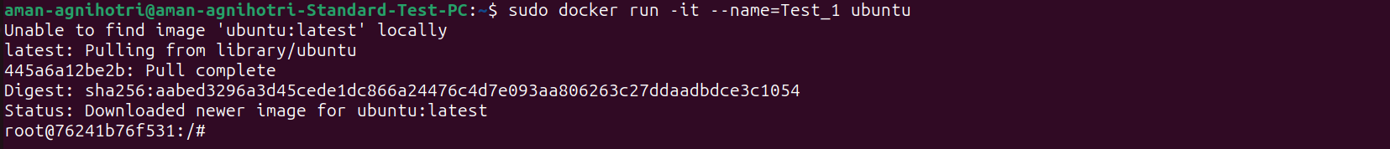
Step 4: Listing all the containers
4.1 Use the below command to list all the containers started and the once which are stopped:
sudo docker ps -a
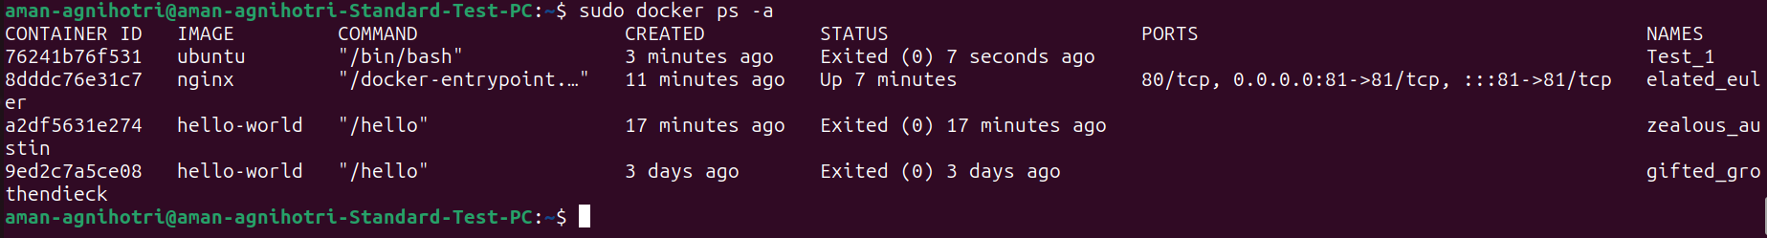

4.2 To list the containers by their ID, use the below command
sudo docker ps -aq
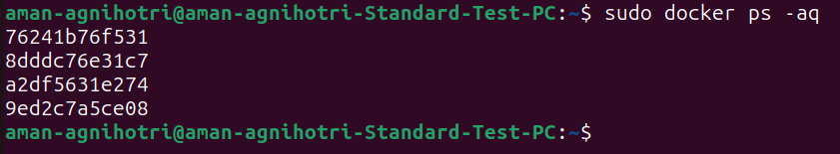

You can see the containers with ID are listed.

4.3 To list the total file size of each container, use the below command:

sudo docker ps -s

4.4 To list the latest created containers, use the following command:

sudo docker ps -l

Step 5: Deleting the container
5.1 Stop the running container and remove it using the following commands:

sudo docker stop CONTAINER_NAME
sudo docker container rm CONTAINER_NAME
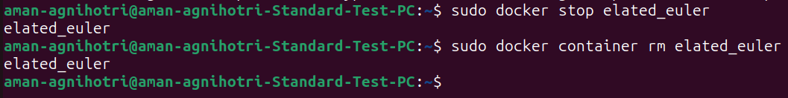
Note: Replace CONTAINER_NAME with the name of the newly created container. In this case CONTAINER_NAME is sweet_brown. The container name may differ from the one shown in the image below.

Step 6: Removing the image
6.1 Remove the image using the command:
sudo docker image rm nginx
